GuardianSphere - Setup & Runbook Document

Overview
GuardianSphere is an AI-powered child wellbeing platform that helps parents, teachers, and counselors proactively support children's academic, emotional, career, and digital safety needs. Built using UiPath Agentic Automation, it provides intelligent insights, personalized recommendations, and early intervention to help every child learn, grow, and thrive.
GuardianSphere is an end-to-end AI-powered student support platform built on UiPath Case Management. It provides intelligent case handling for three major student support domains:
- 💙 Student Wellness
- 🛡️ Digital Safety
- 🎓 Career Guidance
The solution combines a Streamlit Web Application (Python), UiPath Data Fabric, UiPath Maestro Case Management, AI Agents, RPA automation, UiPath Studio Web, UiPath Coded Agents and Email communication into a single automated workflow.

Solution Architecture
Parent / Teacher / Student
│
▼
Streamlit Frontend (Python)
│
▼
UiPath Data Fabric
│
▼
UiPath Case Management
│
▼
AI Multi-Agent Workflow
│
▼
Report Generation & Email Delivery
“We also developed a dedicated Yoga Agent using a UiPath Coded Agent that runs daily to deliver a personalized wellness tip of the day to students and parents, encouraging healthy habits and overall wellbeing.”

Prerequisites
Before running the solution, ensure the following are available:
- Python 3.10 or later
- Visual Studio Code
- Streamlit
- UiPath Automation Cloud / Orchestrator
- UiPath Case Management
- UiPath Data Fabric
- UiPath Agent Builder
- UiPath Integration Service (configured connections)

Step 1 – Import the Entity Schema into Data Fabric
- Download the Entity Schema file (Location: https://github.com/mjworks757/hackathon26_138/blob/main/Code%20Backups/Entities%20Schema.json).
- Navigate to Data Fabric.
- Go to Import/Export → Import Schema.
- Select the downloaded Entities Schema.json file.
- The Case Management entity will be displayed. Select the Import checkbox.
- Click the Import button to import the entity into Data Fabric.
Once you complete Step 3, "Deploy Solution Package(s)," the following two entities will be available in Data Fabric:
- Student Performance Details
- Student Reports

Step 2 – Upload Solution Package(s)
- Download the solution packages from the following locations:
  - GuardianSphere Solution: https://github.com/mjworks757/hackathon26_138/blob/main/Code%20Backups/Solution/GuardianSphere%20Solution-1.0.34.zip
  - YogaTips Using Coded Agent Solution: https://github.com/mjworks757/hackathon26_138/blob/main/Code%20Backups/Solution/YogaTips%20Using%20Coded%20Agent%20Solution-1.0.1.zip
- Open UiPath Orchestrator
- Navigate to Tenant → Solutions → Packages
- Click Upload
- Upload both downloaded solution packages.

Step 3 – Deploy Solution Package(s)
- Open UiPath Orchestrator.
- Navigate to Tenant → Solutions → Packages.
- Verify that the GuardianSphere Solution and YogaTips Using Coded Agent Solution packages are listed.
- For each package:
  - Click the three dots (⋮) on the right.
  - Select Deploy.
  - Review the deployment settings and click Deploy to start the deployment.
- If you encounter any connection-related issues during deployment, edit the affected connection and change the Authentication Type to Configurable by Users, then continue with the deployment.

Step 4 – Validate Assets
- Open the GuardianSphere Solution under the Shared folder in UiPath Orchestrator.
- Navigate to the Assets tab.
- Locate the SenderTwilioPhoneNumber asset.
- Verify that its value is +14155238886.
- If the value is different, update it to +14155238886 and save the changes.
Note: An Assets Reference Sheet has also been uploaded to the GitHub repository. You can refer to it if you need to verify any asset values.
https://github.com/mjworks757/hackathon26_138/blob/main/Code%20Backups/Assets.xlsx

Step 5 – External applications
Since the Streamlit web application uses UiPath APIs to create records in UiPath Data Fabric, an External Application must be configured in UiPath to enable secure API authentication and communication.
- Go to Admin.
- Select External Applications.
- Click Add Application.
- Enter an Application Name (for example, Streamlit).
- Click Add Scope:
  - Resource: Orchestrator
    - Select All under User Scope(s).
    - Apply the same permissions to Application Scope(s).
  - Resource: Data Fabric
    - Select All under User Scope(s).
    - Apply the same permissions to Application Scope(s).
- Set the Redirect URL to: http://localhost:8501/callback
- Click Add to create the External Application.
Note: After the application is created, make sure to copy and securely save the App ID (Client ID) and App Secret (Client Secret), as they will be required to configure the Streamlit application.

Step 6 – Run the Streamlit Frontend

1. Extract the Frontend
- Download the ZIP file from the following location:
https://github.com/mjworks757/hackathon26_138/blob/main/GuardianSphere%20Frontend%20Application/GuardianSphere.zip
- Unzip the provided project
- Open the extracted folder in Visual Studio Code.
- Move the project folder to your preferred location (Example: C:\Users\Admin\Documents\GuardianSphere)
- Open the project in Visual Studio Code.
- Navigate to the 2_Parent_Concern.py file.
- Update the following values:
- Line 20: Replace the Application ID (Client ID) and Application Secret (Client Secret) with the values generated from the UiPath External Application.
- Lines 23–24: Configure the application to retrieve the Gmail Username and Gmail Password from the Windows Credential Manager using the Python keyring library.
- You can use the sample Python code below as a reference for storing and retrieving credentials from the Windows Credential Manager using keyring.
https://github.com/mjworks757/hackathon26_138/tree/main/Code%20Backups/Other%20Code

2. Open Terminal
- Open a terminal or Command Prompt (Windows)
- Navigate to the project directory.
Example: cd C:\Users\Admin\Documents\GuardianSphere

3. Create Virtual Environment
python -m venv venv

4. Activate Virtual Environment
venv\Scripts\activate

5. Install Dependencies
pip install -r requirements.txt
If you see the message below,
[notice] A new release of pip is available: 26.1.1 -> 26.1.2
[notice] To update, run: python.exe -m pip install --upgrade pip
Upgrade pip by running the following command: python.exe -m pip install --upgrade pip

6. Launch Application
streamlit run main.py
The application will automatically open in your default browser.

Step 7 – Submit a New Case
From the homepage, open the Parent Concern.
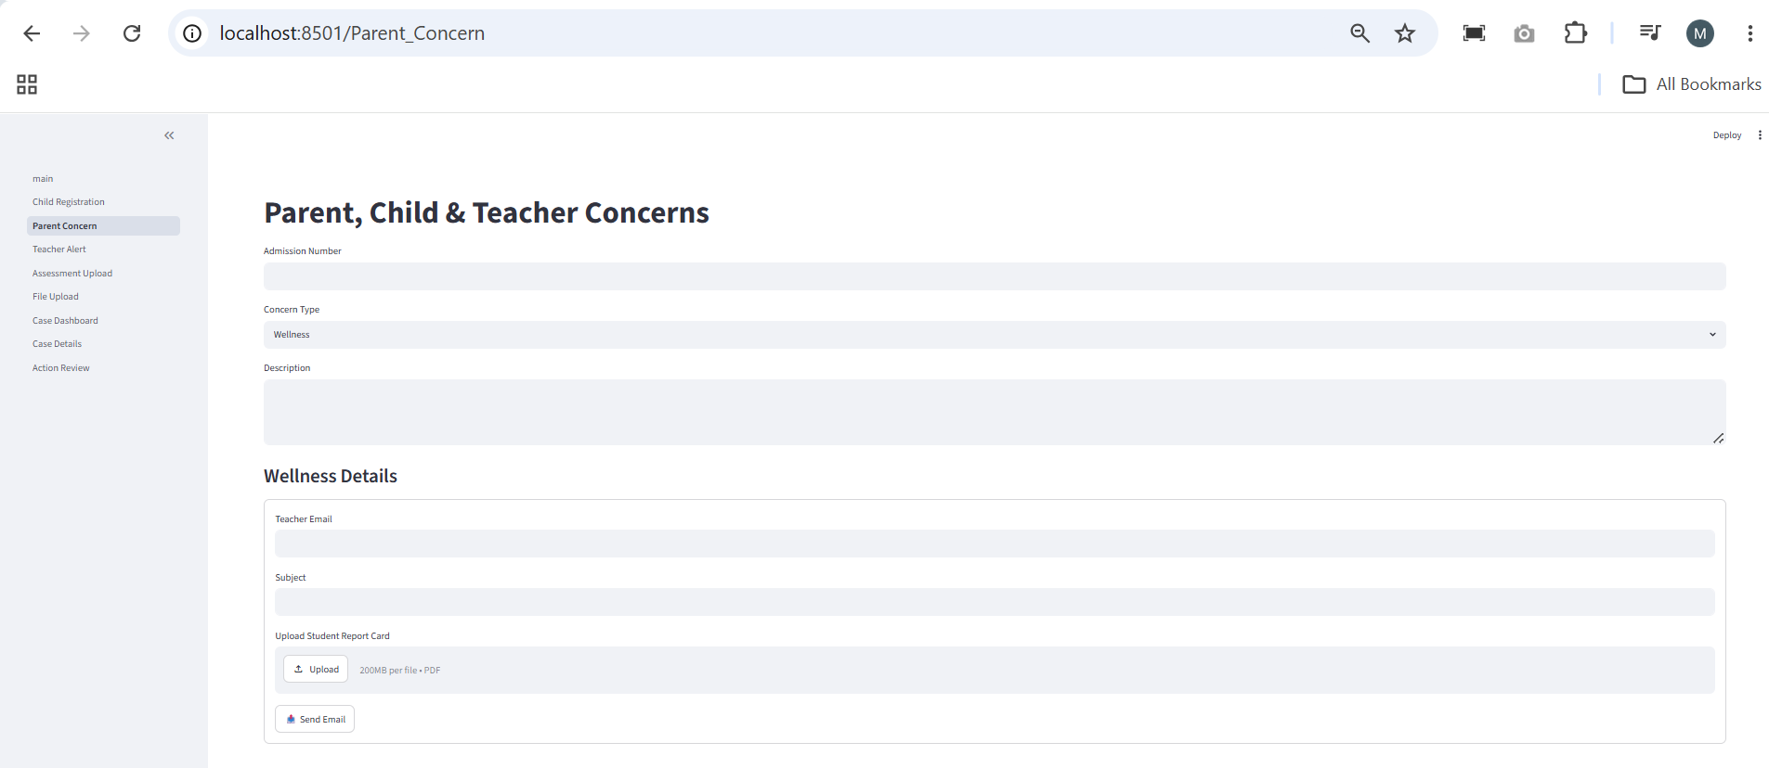
Provide the following standard information:
- Admission Number (Example: ADMN-2026-0001)
- Concern Type (Example: Wellness/Safety/Career)
- Description

The following fields are displayed based on the selected concern type:
- Student Wellness
- Digital Safety
- Career Guidance

Wellness Case
Provide:
- Teacher Email
- Subject (The email subject must include Evaluation Report <student phone number> Example: Evaluation Report +919266711757)
- Student Report card (Only PDF files are supported. You can download the input file from the following location: https://github.com/mjworks757/hackathon26_138/blob/main/Sample%20Input%20Files/Aarav_Student_Report_Card.pdf)
- Click Send Email to submit the case. The email will be sent to the teacher's email address and automatically moved to the AgentHack2026 folder based on the configured email rule.

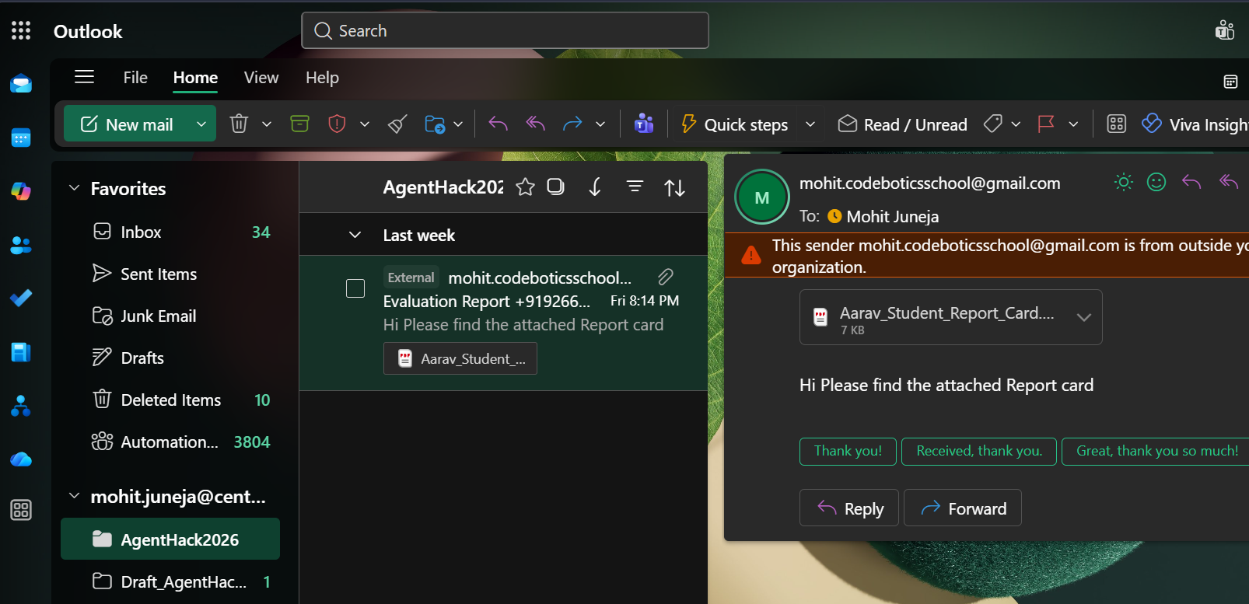

Safety Case
Provide:
- Student Email
- Incident Type (Cyberbullying, "Unsafe Content", "Excessive Screen Time", or "Unknown")
- Upload Screenshot (Currently, only PDF files are supported. You can download the sample input file from the following location: https://github.com/mjworks757/hackathon26_138/blob/main/Sample%20Input%20Files/UiPath_PracticeTest_Attempt2.pdf)
- Click Send Details to submit the case

Career Case
Provide:
- Student Email
- Interests
- Skills
- Upload Report Card (You can download the sample input file from the following location: https://github.com/mjworks757/hackathon26_138/blob/main/Sample%20Input%20Files/Grade5_Student_Report_and_Certificates.docx)
- Certificates (Optional)
- Click Send Details to submit the case

Step 8 – Data Storage (UiPath Data Fabric)
The frontend automatically stores submitted information into UiPath Data Fabric.
Case Management Entity (Main Entity)
Stores:
- Case ID
- Case Type
- Case Description
- Student Admission Number
- Skills
- Interest
- StudentEmail
- Report Card
- Incident Proof
- Certificates
The Case ID is automatically generated by the frontend and stored with the submitted record.

Supporting Entities
- Student Reports (Stores Email Address and File)
- Student Performance Details (Stores WellnessFormSummary, Academic Percentage, Attendance Percentage, ReportCompleteSummaryText and Email Address)

Step 9 – Automatic Case Trigger
GuardianSphere uses an Auto Trigger mechanism.
Whenever a new record is created in the Case Management Entity, the workflow automatically starts.
No manual intervention is required.

Step 10 – Intelligent Case Routing
The system automatically reads the submitted Case Type and routes the request to the corresponding workflow.
Supported workflows:
- Career Guidance
- Student Wellness
- Digital Safety
Each case follows its own specialized AI workflow.

Special Notes:
- The entire solution is event-driven.
- Case creation automatically initiates the workflow.
- No manual orchestration is required after submission.
- AI agents perform analysis and generate recommendations.
- UiPath Case Management tracks the case lifecycle.
- UiPath RPA automates report delivery via email.
- The architecture is modular, scalable, and easily extensible to additional student support scenarios.

